LECTURE RATING AND ANALYSIS SYSTEM
A Project Report submitted in partial fulfilment of the requirement for the award of the degree of

Master of Computer Applications
by
Divyanshu Pandey (14 / 2484200059)
Shiv Pratap Singh (48 / 2484200182)
Neha Sharma (30 / 2484200126)

Group No.: G12
Under the Guidance of
Dr. Sachendra Singh Chauhan, Assistant Professor

Department of Computer Engineering & Applications
Institute of Engineering & Technology



GLA University Mathura – 281406, India
APRIL 2026


Department of Computer Engineering and Applications

GLA University, 17 km Stone, NH#2, Mathura-Delhi Road, P.O. Chaumuhan, Mathura-281406 (U.P.)

Declaration

I hereby declare that the work which is being presented in the M.C.A. Project “Lecture Rating And Analysis System”, in partial fulfillment of the requirements for the award of the Master of Computer Applications and submitted to the Department of Computer Engineering and Applications of GLA University, Mathura, is an authentic record of my own work carried under the supervision of Dr Sachendra Singh Chauhan.
The contents of this project report, in full or in parts, have not been submitted to any other Institute or University for the award of any degree.

Sign ______________________ Sign ______________________
Name of Student: Divyanshu Pandey Name of Student: Shiv Pratap Singh
University Roll No.: 2484200059 University Roll No.:2484200182

Sign ______________________
Name of Student: Neha Sharma
University Roll No.: 2484200126

Certificate

This is to certify that the above statements made by the candidate are correct to the best of my/our knowledge and belief.

_______________________

Supervisor
(Dr. Sachendra Singh Chauhan)
Designation of Supervisor
Dept. of Computer Engg, & App.

______________________ ______________________

Project Co-ordinator Program Co-ordinator
(Dr. Sachendra Singh Chauhan) (Mr. Siddharth Singh)
Assistant Professor Assistant Professor
Dept. of Computer Engg, & App. Dept. of Computer Engg, & App.

Date:

Acknowledgement

I would like to express my deepest gratitude to my project supervisor Dr. Sachendra Singh Chauhan (Assistant Professor), whose unwavering support, invaluable guidance, and profound expertise have been the cornerstone of this project’s success. Their insightful feedback, encouragement, and patience have continually propelled me forward, enabling me to navigate through challenges and strive for excellence. Additionally, I am immensely thankful to the esteemed faculty members of the Department of Computer Application and Engineering at GLA University for their mentor-ship, encouragement, and intellectual contributions, which have enriched this project and broadened my understanding of the subject matter. I am also indebted to my classmates and friends for their camaraderie, encouragement, and unwavering support throughout this journey. Furthermore, my heartfelt appreciation goes to my family for their unconditional love, understanding, and encouragement during the highs and lows of this endeavour. Lastly, I wish to express my sincere thanks to all individuals, organizations, and resources that have directly or indirectly contributed to the realization of this project, shaping it into what it has become today.

Sign Sign

Name of Student: Divyanshu Pandey Name of Student: Neha Sharma University Roll No.: 2484200059 University Roll No.: 2484200126

Sign

Name of Student: Shiv Pratap Singh
University Roll No.: 2484200182

Abstract

In modern educational institutions, teacher and subject evaluation systems often lack accuracy and fairness because they treat all student feedback equally. This results in biased evaluations, particularly when students with low attendance or limited classroom exposure influence the feedback as much as regular attendees. Consequently, such systems fail to accurately represent teaching effectiveness and learning outcomes.
To address this issue, the proposed system introduces an intelligent feedback platform that allows students to rate teachers or specific subjects while incorporating attendance-based weighting. The platform automatically adjusts the credibility of each student's feedback according to their attendance percentage, ensuring that feedback from more actively engaged students has a greater impact on the final evaluation.
A key feature of this system is the implementation of a dynamic weighted rating model. This model calculates the final score by combining student ratings with their level of participation, leading to a more reliable and meaningful evaluation process. By reducing the influence of irregular attendees, the system minimizes bias and prevents manipulation of feedback results.
Furthermore, the platform provides data-driven insights that help institutions analyze teaching performance and subject effectiveness more accurately. Overall, the proposed solution enhances transparency, improves the quality of academic evaluation, and bridges the gap between traditional feedback systems and modern intelligent approache.

CONTENTS
Declaration ii
Certificate ii
Acknowledgement iii
Abstract iv
List of Tables vi
List of Figures vii
CHAPTER 1 Introduction 1-7
  - Overview
  - Motivation
  - Aim
  - Objective
  - Summary of Similar Application
  - Organization of the Project

CHAPTER 2 Software Requirement Analysis 8-18
  - Functional Requirements
    - User Authentication
    - Teacher Login
    - Admin Panel and Data Upload
    - Attendance Retrieval
    - Subject and Topic Selection
    - Feedback Submission
    - Weighted Rating Calculation
    - Feedback Dashboard
    - Data Storage
    - Result Generation
2.2 Non-Functional Requirement
2.2.1 Performance Requirement
2.2.2 Security Requirement
2.2.3 Reliability Requirement
2.2.4 Usability requirement
2.2.5 Scalability Requirement
2.2.6 Accuracy Requirement
2.2.7 Maintainability Requirement
2.2.8 Compatibility Requirement

2.3 System Requirement
2.4 Hardware Requirement
2.5 Software Requirement

CHAPTER 3 Software Design 19-28

3.1 Data Flow Diagrams

3.1.1 Level 0 DFD

3.1.2 Level 1 DFD
3.1.3 Level 2 DFD

3.2 UML Diagram

3.2.1 Use Case diagram

3.2.2 Class Diagram

3.2.3 Activity Diagram

3.3 Database Design

3.3.1 Entity Relationship (ER) Diagram
3.3.2 Tables-Explaining all fields & their data types

CHAPTER 4 Implementation and User Interface 29-35

4.1 Modules

4.2 User Interface Description
4.2.1 Login Screen
4.2.2 Student Dashboard
4.2.3 Teacher Dashboard
4.2.4 Admin Panel
4.2.5 Reports and Results Screen

4.3 Project Snapshot
4.3.1 Home Page
4.3.2 Login Page
4.3.3 Rating Page
4.3.4 Teacher Dashboard Page
4.3.5 About Us Page

CHAPTER 5 Conclusion 36

CHAPTER6 Summary 37

List Of Tables

- Attendance Table 26
- Student Table 26
- Admin Table 26
- Teacher Table 27
- Subject Table 27
- Topic Table 27
- Feedback Table 28

List of Figures
- Figure 1: Comparison Table 3
- Figure 2: Level 0 DFD 9
- Figure 3: Level 1 DFD 10
- Figure 4: Level 2 DFD 11
- Figure 5: Use Case Diagram 12
- Figure 6: Class Diagram 13
- Figure 7: Activity Diagram 14
- Figure 8: E-R Diagram 15

Chapter1 INTRODUCTION

Overview
The project “Lecture Rating and Analysis System” is designed to provide educational institutions with a fair, transparent, and intelligent platform for collecting student feedback. In most schools and colleges, teacher evaluation is often inaccurate because all student ratings are treated equally, regardless of their attendance or exposure to classroom teaching. Lecture Rating and Analysis System solves this problem by introducing a weighted rating mechanism where feedback from regular and active students has higher credibility than feedback from students with poor attendance. The system allows students to rate teachers and subjects on a topic-wise basis, and every rating is processed through a weighted formula that adjusts the score based on the student’s attendance. This ensures that final teacher evaluations reflect true academic participation rather than simple averages. The platform also adapts seamlessly across multiple departments, subjects, and class sections, making it suitable for schools, colleges, and universities. A major innovation of Lecture Rating and Analysis System is its automated attendance- based credibility algorithm, which prevents bias, eliminates manipulation, and improves the reliability of feedback. By integrating secure data management, validated attendance records, and real-time calculations, the system ensures accuracy, scalability, and fairness. Built with modern web technology and database support, Lecture Rating and Analysis System focuses on performance, transparency, and ease of use. Overall, the platform bridges the gap between traditional feedback collection and data-driven evaluation, allowing institutions to improve teaching quality, enhance student engagement, and create a more accountable academic environment.

Motivation
The motivation behind the project Lecture Rating And Analysis System originates from the limitations and unfairness present in traditional academic feedback systems. In most institutions, teacher or subject evaluation does not consider the student’s academic involvement or attendance, which results in biased and inaccurate results. Students with very low participation often influence feedback just as much as highly attentive learners, making it difficult to differentiate between informed responses and uninformed ones. This reveals the need for a modern, credible, and data- driven feedback mechanism. The project takes inspiration from the idea of using attendance- based credibility as a measurable factor to determine the reliability of student feedback. By integrating weighted scoring and mathematical analysis, the system solves two major issues faced by educational institutions:
    - Ensuring fair and unbiased feedback scoring, and
    - Preventing manipulation or misleading evaluation by low-attendance students.
Apart from technological innovation, the project carries strong educational motivation— improving transparency, enhancing teacher performance evaluation, and ensuring that feedback truly represents classroom participation. The ultimate goal is to create a fair academic ecosystem where institutions can make informed decisions, teachers can improve teaching quality, and students can contribute meaningfully to the academic environment.

Aim
The aim of this project is to design and develop an intelligent feedback and rating system that evaluates teachers and subjects in a fair, accurate, and transparent manner based on student attendance. The system seeks to improve the reliability of academic feedback by introducing a weighted-rating mechanism that considers student participation, ensures unbiased scoring, and delivers meaningful insights for academic evaluation. Additionally, the platform aims to eliminate manipulation and inaccuracy by integrating automated attendance weighting and secure data management. Through this combination of dynamic scoring and real-time evaluation, the project aims to provide educational institutions with a credible and scalable method for teacher assessment. Ultimately, Lecture Rating Analysis System empowers schools and colleges to enhance teaching quality, improve feedback standards, and promote a more accountable and data-driven academic environment.

Objective
- To provide a fair and transparent teacher evaluation system using credibility-based feedback.
- To calculate weighted ratings by integrating attendance as a key factor in feedback accuracy.
- To eliminate bias and manipulation caused by low-attendance or uninformed evaluations.
- To build a scalable and secure digital platform for feedback collection and analysis.
- To generate real-time, meaningful performance insights for teachers and academic departments.
- To improve the overall academic environment by promoting accountability and student participation.

Summary of Similar Application
Several feedback and academic rating platforms are currently available for educational institutions, but most of them still rely on traditional and uniform rating mechanisms. Existing systems used in colleges and universities, such as generic feedback portals, learning management systems, or basic survey-based applications, provide a common interface for collecting student feedback. While these tools allow rating and reviews, they typically treat all responses equally without evaluating the credibility of the student giving the feedback. Some modern academic platforms include analytics and visualization features, but they still lack intelligent weighting or validation based on student participation and attendance. As a result, manipulation and biased evaluations can affect the final results. In many cases, even students who rarely attend classes are able to give feedback that holds the same value as students with high attendance, reducing the fairness and reliability of the evaluation. Furthermore, existing systems often focus on collecting feedback but do not integrate a mathematical model or automated scoring mechanism. They also fail to identify the credibility of the feedback giver, which is essential for meaningful academic assessment. These limitations highlight the need for a more accurate, attendance-aware feedback system like Lecture Rating Analysis System, which ensures unbiased evaluation and supports improved decision-making for academic institutions.

Existing System | Proposed System: Lecture Rating Analysis System
Uses simple feedback forms or basic survey  portals | Uses weighted attendance-based rating  Mechanism
Treats all responses equally | Ratings are weighted based on attendance Percentage
Students with low attendance influence the  evaluation equally | Low-attendance students have reduced impact
Prone to bias, manipulation, and inaccurate  results | Ensures fairness, transparency, and credibility
No mathematical model for evaluation | Uses weighted rating formula for calculation
Evaluation does not reflect true participation | Reflects real engagement and classroom  Exposure
Limited insights for academic decision making | Provides meaningful and data-driven analytics
Static system, not scalable | Secure, scalable, and suitable for schools,  colleges, universities

Figure 1 Comparison Table

Organization of the Project
This project report is organized into systematic chapters that document the complete development of the Lecture Rating Analysis System . Each chapter covers critical aspects ranging from the conceptual foundation to the implementation and results. The structure of the report is as follows:

Chapter 1 – Introduction
This chapter introduces the project by presenting the overview, motivation, aim, and objectives. It also includes a summary of existing applications and highlights the limitations of current feedback systems. The chapter explains the need for a weighted attendance-based rating platform and establishes the context for the proposed solution.

Chapter 2 – Software Requirement Analysis
This chapter focuses on identifying and analysing the system requirements. It covers functional and non-functional requirements, feasibility study, software and hardware requirements, and system specifications. These elements ensure a clear understanding of user needs and guide further design and implementation stages.

Chapter 3 – Software Design
This chapter describes the design architecture of the system. It includes Data Flow Diagrams (Level 0, Level 1, Level 2), UML diagrams (Class, Use Case, Sequence, and Activity diagrams), and the complete database design including E-R diagrams and relational schema. It illustrates how different components interact and represent the internal working of Lecture Rating Analysis System.

Chapter 4 – Implementation and User Interface
This chapter explains the development and coding phases of the project. It describes individual modules, algorithms used for calculating weighted scores, and provides snapshots of the user interface. It demonstrates how the conceptual design is translated into a functioning software application.

Chapter 5 – Software Testing
This chapter discusses the testing activities performed to validate the system’s reliability and correctness. It includes different levels of testing, validation criteria, and test case design to ensure that the entire platform is accurate, scalable, secure, and user-friendly.

Chapter 6 – Conclusion
This chapter summarizes the key outcomes and impact of the project. It highlights the successful implementation of the weighted feedback model and the contribution of Lecture Rating Analysis System towards improving transparency and fairness in academic feedback systems.

Chapter 7 – Summary
This chapter provides an overall recap of the project. It briefly outlines the objectives achieved, methodology followed, technologies used, and the significance of Lecture Rating Analysis System in enhancing academic evaluation.

Chapter 2 SOFTWARE REQUIREMENT ANALYSIS
Software Requirement Analysis identifies what the system must accomplish and what users expect from it. For this project, it defines needs such as feedback collection, attendance integration, weighted rating calculation, and secure data handling. It provides a clear foundation for designing the system components, ensures that evaluation is fair and credible, and guides successful development of the Lecture Rating And Analysis System platform.

Functional Requirements

User Authentication
The system must allow students to log in securely using Roll Number as the username and Date of Birth (DDMMYY format) as the password. The system should validate credentials and restrict unauthorized access. Incorrect attempts must be handled safely without exposing user information. Example: A student enters Roll No: 12345 and DOB: 150804. After verification, the student is redirected to the dashboard.

Teacher Login
There will be a login option for teachers on the home page. Teachers should have read-only access to view their feedback reports. Teachers can:
      - View final weighted rating
      - View topic-wise rating
      - View suggestions/remarks for low scoring topics Teachers cannot modify or delete feedback.

Admin Panel and Data Upload
The admin must upload and manage all master data, such as:
      - Student attendance
      - List of students and teachers
      - Subject and topic details Admin is the only role with edit permissions for this data.

Attendance Retrieval
The system must fetch each student’s attendance from the database for weighted score calculation.
Example: When S1 logs in, their attendance value is loaded automatically.

Subject and Topic Selection
Students must be able to select a subject and topic before rating. Example: A student selects Mathematics → Algebra.

Feedback Submission
The system must allow students to submit feedback using numeric ratings strictly from 1 to 5.
Example: A student gives a rating of 4 for a topic.

Weighted Rating Calculation
The system must calculate feedback using the attendance-based weighted rating formula. Example: A student with 90% attendance has a higher influence than a student with 40% attendance.

Feedback Dashboard
The system must provide dashboards where teachers can view feedback statistics and weighted results.

Data Storage
The system must securely store:
      - Student details
      - Attendance
      - Ratings
      - Weighted results
      - Subject/topic lists Data should be retrievable and protected from unauthorized access.

Weighted Rating Calculation
The system must calculate feedback using the attendance-based weighted rating formula. Example: A student with 90% attendance has a higher influence than a student with 40% attendance.

Feedback Dashboard
The system must provide dashboards where teachers can view feedback statistics and weighted results.

Data Storage
The system must securely store:
      - Student details
      - Attendance
      - Ratings
      - Weighted results
      - Subject/topic lists Data should be retrievable and protected from unauthorized access.

Weighted Rating Calculation
The system must calculate feedback using the attendance-based weighted rating formula. Example: A student with 90% attendance has a higher influence than a student with 40% attendance.

Feedback Dashboard
The system must provide dashboards where teachers can view feedback statistics and weighted results.

Weighted Rating Calculation
The system must calculate feedback using the attendance-based weighted rating formula. Example: A student with 90% attendance has a higher influence than a student with 40% attendance.

Weighted Rating Calculation
The system must calculate feedback using the attendance-based weighted rating formula. Example: A student with 90% attendance has a higher influence than a student with 40% attendance.

Feedback Dashboard
The system must provide dashboards where teachers can view feedback statistics and weighted results.

Data Storage
The system must securely store:
      - Student details
      - Attendance
      - Ratings
      - Weighted results
      - Subject/topic lists Data should be retrievable and protected from unauthorized access.

Result Generation
The system must compute and display:
      - Final weighted rating
      - Topic-wise rating
      - Average rating Example: Final rating for Mathematics = 4.2 after applying the weighted formula. The system must compute and display:
      - Final weighted rating
      - Topic-wise results
      - Average ratings The proposed weighted feedback system solves the existing fairness issues in educational feedback mechanisms and produces accurate and reliable evaluations.

Weighted Rating Calculation
The system must calculate feedback using the attendance-based weighted rating formula. Example: A student with 90% attendance has a higher influence than a student with 40% attendance.

Feedback Dashboard
The system must provide dashboards where teachers can view feedback statistics and weighted results.

Data Storage
The system must securely store:
      - Student details
      - Attendance
      - Ratings
      - Weighted results
      - Subject/topic lists Data should be retrievable and protected from unauthorized access.

Result Generation
The system must compute and display:
      - Final weighted rating
      - Topic-wise rating
      - Average rating Example: Final rating for Mathematics = 4.2 after applying the weighted formula. The system must compute and display:
      - Final weighted rating
      - Topic-wise results
      - Average ratings The proposed weighted feedback system solves the existing fairness issues in educational feedback mechanisms and produces accurate and reliable evaluations.

Weighted Rating Calculation
The system must calculate feedback using the attendance-based weighted rating formula. Example: A student with 90% attendance has a higher influence than a student with 40% attendance.

Feedback Dashboard
The system must provide dashboards where teachers can view feedback statistics and weighted results.

Data Storage
The system must securely store:
      - Student details
      - Attendance
      - Ratings
      - Weighted results
      - Subject/topic lists Data should be retrievable and protected from unauthorized access.

Result Generation
The system must compute and display:
      - Final weighted rating
      - Topic-wise rating
      - Average rating Example: Final rating for Mathematics = 4.2 after applying the weighted formula. The system must compute and display:
      - Final weighted rating
      - Topic-wise results
      - Average ratings The proposed weighted feedback system solves the existing fairness issues in educational feedback mechanisms and produces accurate and reliable evaluations.

Weighted Rating Calculation
The system must calculate feedback using the attendance-based weighted rating formula. Example: A student with 90% attendance has a higher influence than a student with 40% attendance.

Feedback Dashboard
The system must provide dashboards where teachers can view feedback statistics and weighted results.

Data Storage
The system must securely store:
      - Student details
      - Attendance
      - Ratings
      - Weighted results
      - Subject/topic lists Data should be retrievable and protected from unauthorized access.

Result Generation
The system must compute and display:
      - Final weighted rating
      - Topic-wise rating
      - Average rating Example: Final rating for Mathematics = 4.2 after applying the weighted formula. The system must compute and display:
      - Final weighted rating
      - Topic-wise results
      - Average ratings The proposed weighted feedback system solves the existing fairness issues in educational feedback mechanisms and produces accurate and reliable evaluations.

Non-Functional Requirement

Performance Requirement
The system must respond quickly and efficiently, ensuring smooth feedback submission and rating calculations. Weighted computation, dashboard updates, and attendance retrieval must complete within acceptable time limits.
Example: When a student submits a rating, the weighted score and updated result should generate within 2–5 seconds.

Security Requirement
The system must ensure high-level data protection and secure database access. Sensitive data like attendance, ratings, and login credentials must be encrypted and protected against unauthorized access.
Example: Student details are stored in the database using secure encryption so even if a breach occurs, the data remains unreadable.

Reliability Requirement
The system must work consistently without crashing or system failure during rating submission and report generation. Database connectivity and rating calculations should remain stable for all users.
Example: Even if multiple students submit feedback at the same time, the system should remain fully responsive.

Usability Requirement
The system must be easy to use for both students and teachers. The interface should be simple, clear, and intuitive so users can submit and view feedback without confusion.
Example: A student must be able to log in and submit a rating without external assistance.

Scalability Requirement
The system must handle large numbers of students, subjects, and ratings without performance issues.
Example: If 500 students submit ratings at the same time, the system must calculate results smoothly and without delays.

Accuracy Requirement
The system must generate correct weighted ratings using the attendance-based formula. Calculations should be consistent across subjects and topics without errors.
Example: If two students have different attendance percentages, the system should calculate different weighted values even if the rating is the same.

Maintainability Requirement
The system should be easy to maintain, update, and expand. Admins or developers should be able to modify subjects, attendance data, or rating logic without affecting other modules.
Example: If a new subject is added or rules change, the admin should be able to update it easily.

Compatibility Requirement
The system must work properly across modern browsers and devices.
Example: The platform must run smoothly on Google Chrome, Microsoft Edge, or Firefox on Windows or mobile devices.

Availability Requirement
The system should be available and accessible at all times except during scheduled maintenance. Students should be able to submit feedback whenever needed.
Example: If a student logs in at night for feedback, the system should be available without downtime.

System Requirement
- The system must support student, teacher, and admin login functionality.
- The system must allow secure attendance upload and rating submission.
- The system must handle data storage for subjects, topics, feedback, and weighted ratings.
- The system must calculate weighted scores based on attendance and generate results/analytics.
- The system must support scalable deployment for multiple concurrent users in a school or college environment.

Hardware Requirement

For Users (Students/Teachers)
- Laptop/PC with basic dual-core processor or higher
- Minimum 4–8 GB RAM
- Browser access (no webcam or mic required)
- Stable internet connection

For Admin
- Laptop/PC with i3/i5 processor
- Minimum 4–8 GB RAM
- Ability to upload attendance files and master data

For Development
- Laptop/PC with i5/i7 processor
- Minimum 8–16 GB RAM
- SSD storage recommended

Software Requirement

Operating System
- Windows 10 / Windows 11
- Linux / macOS (for development)

Development Tools
- VS Code (Code Editor)
- Microsoft SQL Server(Database)
- Browser: Google Chrome / Edge

Technologies & Frameworks
- React
- CSS[7]
- HTML[6], JavaScript

Deployment Services
- Vercel[8] / Netlify[9] / Local server hosting

Database & Storage
- PostgreSQL for data storage
- Proper access and role-based permissions

Chapter 3 SOFTWARE DESIGN
System design is the foundational phase where the overall architecture, flow, and behavior of the proposed system are defined. It converts all requirements into a structured technical model that guides development. For the project “Lecture Rating And Analysis System”, system design ensures that all modules—authentication, attendance retrieval, feedback collection, weighted rating calculation, and result generation—work together accurately, securely, and efficiently.

Data Flow Diagram

    - Level 0 DFD: Figure 2 shows the Level 0 DFD of the Lecture Rating And Analysis System, representing a high-level overview of data movement between users, the system, and the database.

Lecture Rating Analysis System
Admin
Teacher
Student

Databases

Figure 2: Level 0 DFD

    - Level 1 DFD: Figure 3 is showing the Level 1 DFD of the Lecture Rating And Analysis System.
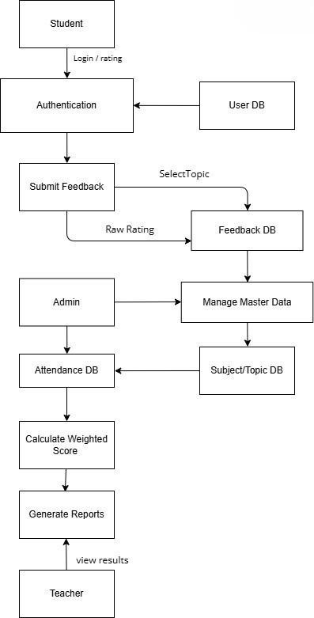
Figure 3 Level 1 DFD

    - Level 2 DFD: Figure 4 showing the Level 2 DFD of the Lecture Rating And Analysis System.
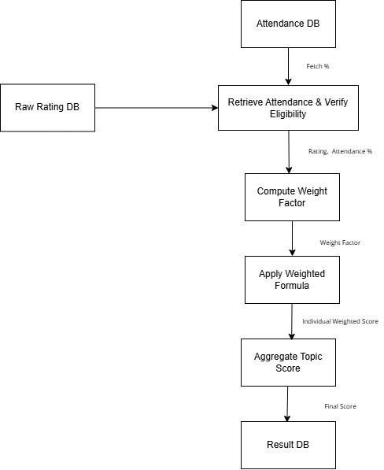
Figure 4 Level 2 DFD

UML Diagram

3.2.1 Use Case Diagram

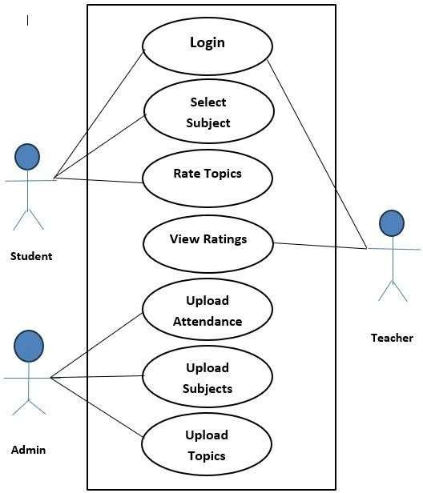

Figure 5 Use Case Diagram

Class Diagram

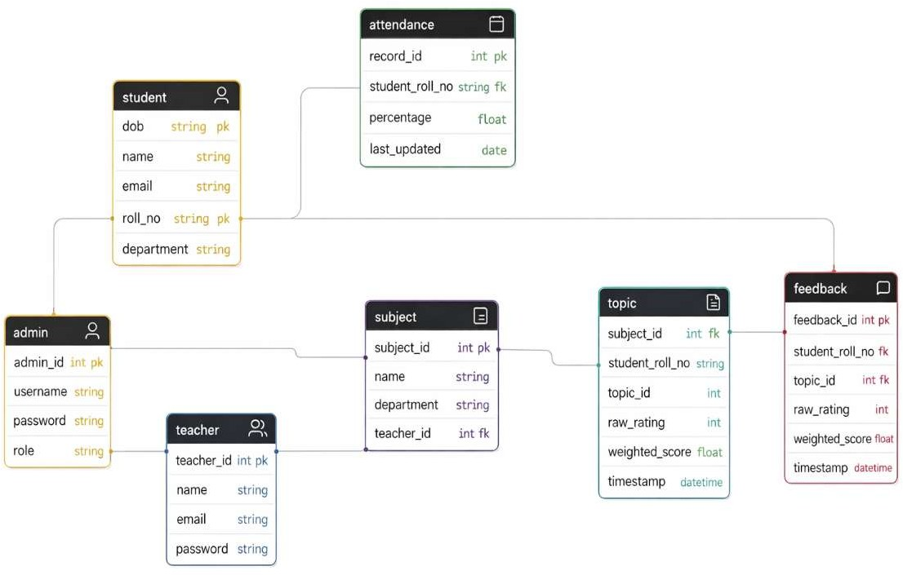

Figure 6 Class Diagram

Activity Diagram

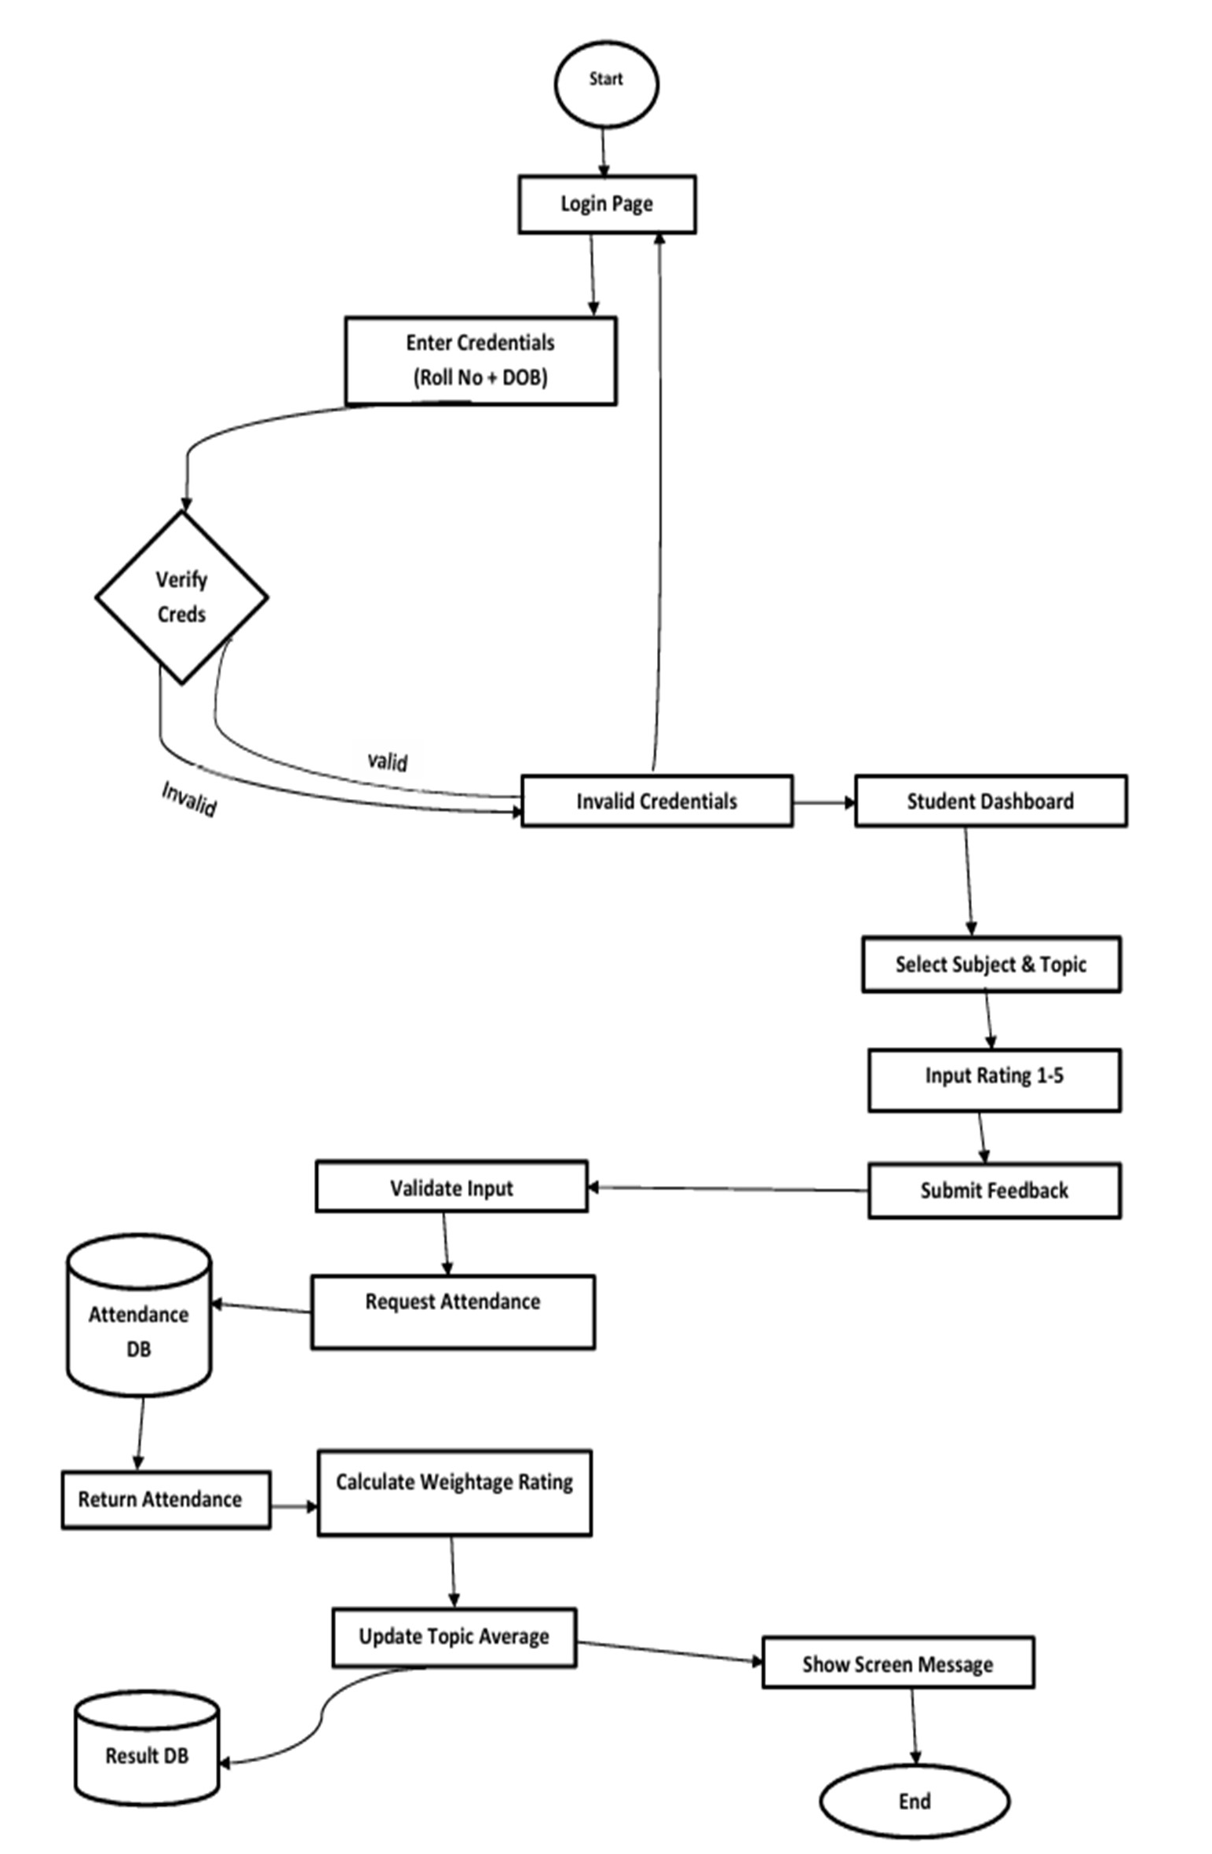

Figure 7 Activity Diagram

Database Design

E-R Diagram

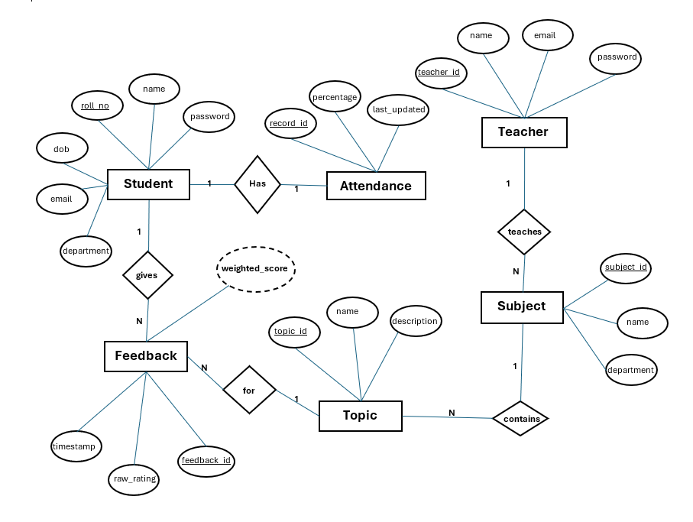

Figure 8 E-R Diagram

    - Tables-Explaining all fields & their data types

1. Attendance Table
Field | Data Type | Description
Record_id | INT (PK) | Unique ID
student_roll_no | VARCHAR(100) | Roll number of the student
percentage | FLOAT | Attendance Percentage
last_updated | DATE | Last date of attendance update
2. Student Table
Field | Data Type | Description
dob | STRING (PK) | Date of birth of Student
name | STRING | Name of Student
email | STRING(50) | Email Id of student
roll_no | STRING | Roll no of the student
department | STRING(50) | Department of student

 | 3. Admin Table
 | Field | Data Type | Description
 | admin_id | INT(PK) | Unique Id of Admin
 | username | STRING | Username of Admin
 | password | STRING | Encrypted password
 | role | STRING | Role of Admin
 | 4. Teacher Table
 | Fiel | Data Type | Description
 | teacher_id | INT (PK) | Unique Id of teacher
 | name | STRING | Name of the teacher
 | email  password | STRING  STRING | Email Id of teacher  Encrypted password

5. Subject Table
Field | Data Type | Description
subject_id | INT (PK) | Subject code
name | STRING | Name of the Subject
department | STRING | Department name
teacher_id | INT | Teacher who is teaching the subject
6. Topic Table
Field | Data Type | Description
topic_id | INT (PK) | Unique Id of topic
subject_id | INT | Subject code
name | STRING | Name of the Topic
description | STRING | Description of the topic
7. Feedback Table
Field | Data Type | Description
feedback_id | INT (PK) | Unique Id for feedback
student_roll_no | STRING | Roll number of the student
Topic_id | INT | Unique Id of Topic
raw_rating | INT | Rating given by student
Weighted_score | FLOAT | Rating calculated using formula
timestamp | DATETIME | Time

Chapter 4 IMPLEMENTATION AND USER INTERFACE
Lecture Rating And Analysis System is implemented as a modular, scalable web application with a clear separation of concerns. The system uses a Html, CSS-based frontend for an interactive and responsive user interface, a backend built using C#[3] for handling business logic, and Microsoft SQL server[4] for secure and reliable data storage. The platform manages core operations such as user authentication, attendance handling, feedback submission, weighted rating computation, and report generation. It can be hosted on cloud platforms (such as Vercel for frontend and a suitable cloud provider for backend and database) with secure communication between layers. The user interface focuses on simplicity and clarity, providing separate views for students, teachers, and administrators. Students can log in, select subjects/topics, and submit ratings easily; teachers can view topic-wise and final ratings; and admins can upload attendance, manage master data, and monitor overall performance analytics.

Modules

User Login & Role Management
This module manages authentication and access control for three types of users—students, teachers, and administrators. Students log in using their roll number as username and date of birth (DDMMYY) as password, while teachers and admins log in using their assigned credentials. After validation, each user is redirected to their respective dashboard with role- based permissions. This module ensures that only authorized users access features like feedback submission, report viewing, or data management, and forms the secure entry point to the system.

Admin & Master Data Management
This module is responsible for managing all master data used in the system. The admin can upload and update student details, attendance records, teacher information, and subject–topic mappings. It ensures that data required for feedback and weighted calculations is accurate and up to date. By centralizing control with the admin, this module prevents unauthorized modification of core records and maintains the integrity of institutional data.

Subject and Topic Management
This module handles the creation, updating, and organization of subjects and their corresponding topics for different classes or semesters. It ensures that students can only give feedback on valid and active subjects/topics assigned to them. The module allows the admin to map teachers to specific subjects and topics so that ratings are correctly associated with the respective faculty. This forms the basis for topic-wise evaluation and detailed performance reports.

Feedback Collection Module
This module enables students to provide feedback for selected subjects and topics using a numeric rating scale from 1 to 5. The interface is designed to be simple and quick, allowing students to select a topic and submit their rating in a few steps. It validates each rating, prevents duplicate.
Unauthorized submissions, and ensures that only eligible students (based on records) can give feedback. This module acts as the primary input source for the rating engine.

Weighted Rating & Calculation Module
This is the core logic module of Lecture Rating Analysis System. It applies the attendance- based weighted rating formula to each student’s feedback. Ratings from students with higher attendance are given more weight compared to those with low attendance. The module aggregates all individual weighted scores to generate final ratings for each topic and subject. It ensures that evaluation is mathematically accurate, unbiased, and truly reflective of classroom participation, thereby increasing the credibility of the feedback process.

Weighted Rating & Calculation Module
This is the core logic module of Lecture Rating Analysis System. It applies the attendance- based weighted rating formula to each student’s feedback. Ratings from students with higher attendance are given more weight compared to those with low attendance. The module aggregates all individual weighted scores to generate final ratings for each topic and subject. It ensures that evaluation is mathematically accurate, unbiased, and truly reflective of classroom participation, thereby increasing the credibility of the feedback process.

Reports & Dashboard Module
This module generates visual and tabular reports for teachers and administrators. Teachers can view final ratings, topic-wise performance, and remarks or indicators for topics that scored low, helping them identify areas that require improvement or reteaching. Admins can access overall summaries, department-wise analytics, and attendance–rating correlations. The dashboards are designed to be easy to interpret, offering clear insights that support better academic decisions and quality enhancement.

User Interface Description
The User Interface (UI) of Lecture Rating Analysis System is designed to be simple and intuitive, ensuring that students, teachers, and admins can navigate the system with ease. The application uses a clean layout with clearly defined sections and role-based navigation. Each user interacts with the system through a dedicated dashboard displaying only the features relevant to their role.

Login Screen
The login screen provides three login options: Student, Teacher, and Admin. Students enter their Roll Number and Date of Birth (DDMMYY), while teachers and admins use their assigned credentials. The interface includes a clean form layout and error messages for invalid entries.

Student Dashboard
The student dashboard presents the list of available subjects and topics. Students can:
      - Select a subject
      - Choose a topic
      - Submit a rating from 1 to 5 The screen emphasizes simplicity so students can quickly provide feedback without confusion.

Teacher Dashboard
Teachers can view:
      - Final weighted ratings
      - Topic-wise ratings
      - Remarks for low-rated topics: The interface highlights result clearly, focusing on readability and actionable insights for teachers.

Admin Panel
Admins have access to master data operations, including:
      - Uploading attendance
      - Adding students and teachers
      - Managing subjects and topics: The user interface offers buttons, upload fields, and organized forms for seamless working.

Reports and Results Screen
This interface displays the computed weighted ratings and summary results. Graphs, tables, or summary cards may be used to visualize performance indicators. The design ensures clarity so that users can interpret results easil.

Project Snapshot

    - Home Page



    - Login Page

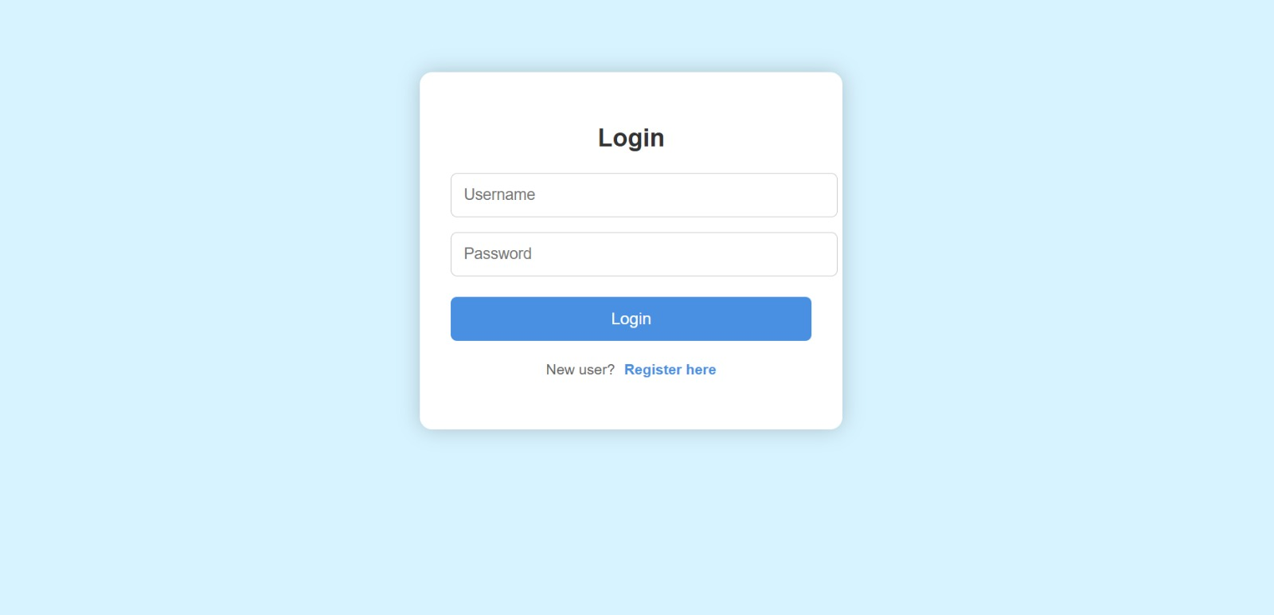

    - Rating Page

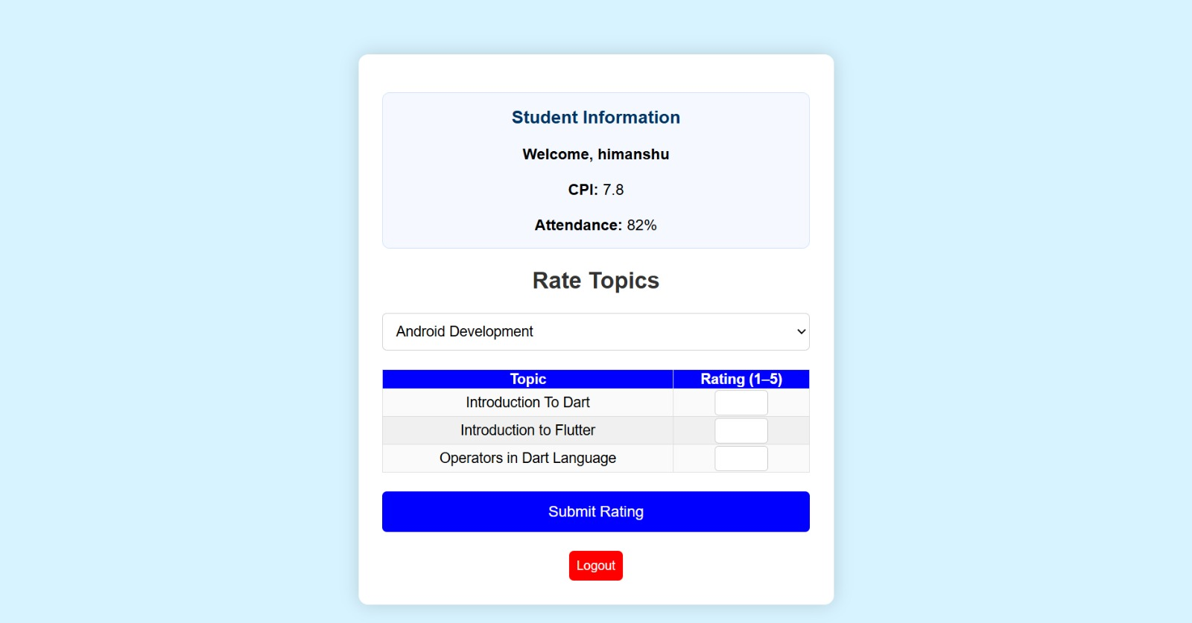

    - Teacher Dashboard Page

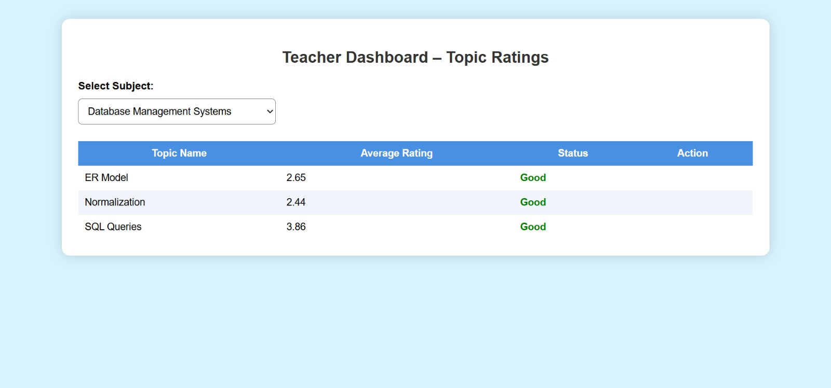

    - Admin Page

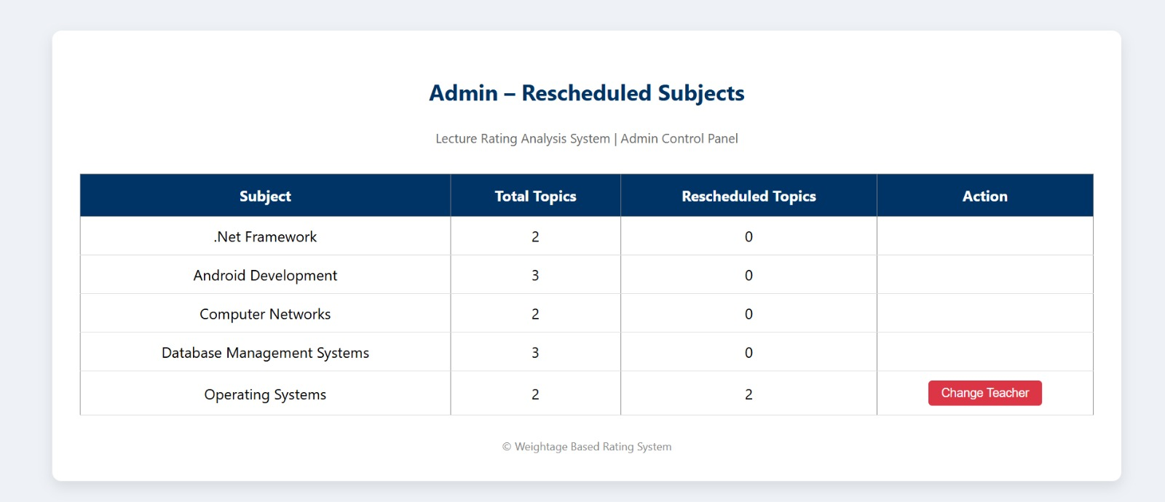

    - About Us Page

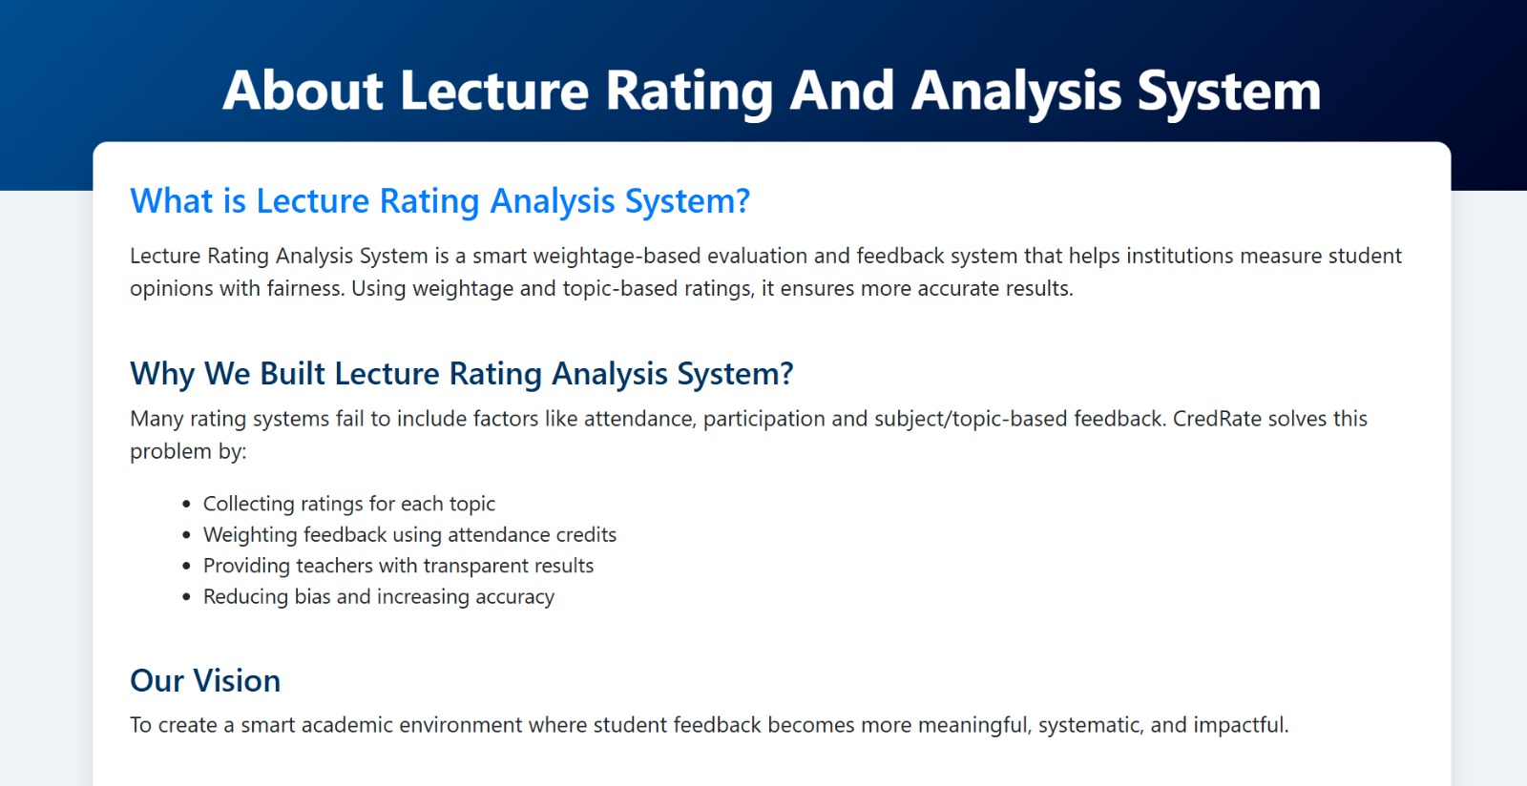

Chapter 5 CONCLUSION
The Lecture Rating And Analysis System has been successfully designed and implemented to address one of the major challenges in traditional feedback systems used in schools, colleges, and universities. Conventional evaluation methods often treat all student feedback equally, without considering the credibility of the student giving the rating. This leads to biased results, manipulation, and inaccurate assessment of teaching quality. Lecture Rating Analysis System overcomes these limitations by introducing an attendance-based weighted rating mechanism that improves fairness, transparency, and reliability in academic feedback. The system provides a complete end-to-end feedback solution—from user authentication and attendance retrieval to subject selection, rating submission, weighted score computation, and results visualization. Through the use of a structured mathematical formula and secure data management, the platform ensures that students with higher attendance contribute more weight to the final rating, thus creating a more meaningful representation of academic participation. Another significant achievement of the project is the ability to generate topic-wise and final ratings that help teachers and administrators identify specific areas of improvement. Teachers can view feedback reports, compare ratings, and receive remarks for low-rated topics, enabling a targeted approach to improving teaching quality. The system also provides dashboards and analytics to assist academic administrators in making informed decisions for curriculum planning and performance monitoring. From a technical standpoint, the project demonstrates the successful integration of modern web technologies, database-driven design, modular architecture, and secure access control. The structured separation of roles (Student, Teacher, Admin) ensures smooth system operation, data integrity, and maintainability. Due to its scalability and flexible design, Lecture Rating Analysis System can be deployed across different departments and institutions with minimal modification.
Overall, Lecture Rating And Analysis System achieves the primary objectives of providing a fair, secure, and intelligent academic feedback platform. By transforming simple ratings into weighted and meaningful evaluations, the system enhances the credibility of teacher assessment and promotes continuous academic improvement.
With future enhancements such as written feedback options, advanced analytics, and integration with academic management software, the platform has strong potential to evolve into a widely adopted educational evaluation solution.

Chapter 6 SUMMARY
The Lecture Rating And Analysis System project is designed to provide a modern, fair, and data-driven feedback platform for educational institutions. Instead of relying on traditional feedback forms where all student ratings are treated equally, Lecture Rating Analysis System introduces an attendance-based weighted evaluation mechanism. This approach ensures that feedback from students with higher participation has a greater impact on the final score, resulting in more credible and unbiased assessment of teaching quality. The system helps identify key performance areas by generating subject-wise and topic-wise ratings, enabling institutions to enhance academic standards and teaching efficiency. One of the major strengths of the system is its ability to eliminate manipulation and incorrect evaluation caused by low-attendance students. With secure role- based access, only authorized students, teachers, and administrators can interact with the system. The admin is responsible for uploading attendance, student, and subject details, which ensures accuracy and data consistency. Teachers can view feedback reports, rating summaries, and remarks for low-rated topics—allowing them to improve teaching strategies and focus on areas where students struggle. From a technical perspective, Lecture Rating And Analysis System demonstrates the successful use of modern web development tools like html, CSS for the frontend and Microsoft SQL server for secure and efficient data storage. The platform supports a scalable architecture, allowing multiple students and teachers to submit and view feedback without performance issues. The user interface is kept clean and straightforward, guiding users through all essential operations such as login, feedback submission, and report viewing. Administrators are provided with a dedicated panel to manage subjects, attendance, and teacher-wise performance reports, making it easy to maintain and monitor institutional feedback flow. Overall, the Lecture Rating Analysis System effectively addresses the limitations of traditional academic feedback mechanisms. By combining attendance-based scoring, structured data handling, and user-friendly interfaces, the platform helps create a fair and transparent evaluation process. With further enhancements like graphical analytics, written feedback features, and integration with academic management systems, It can serve highly impactful academic evaluation tool for various educational environments.

APPENDICES

Appendix A – Project Summary
Lecture Rating And Analysis System is an attendance-based feedback and rating system designed for schools, colleges, and universities. It allows students to give topic- wise feedback, computes weighted ratings based on attendance, and generates reliable and unbiased evaluation reports for teachers and academic departments.

Appendix B – Tools & Technologies
- Frontend: HTML, CSS, Bootstrap[5]
- Backend: C#, ASP.Net[2]
- Deployment: Netlify
- Authentication & Role Management: Student / Teacher / Admin access control

Appendix C – Hardware Requirements
- Laptop or PC with dual-core/i3/i5 processor
- 4–8 GB RAM
- Internet connectivity

Appendix D – Software Requirements
- Windows 10/11
- Visual Studio[10]
- .Net Framework [1]

Appendix E – Major Functional Modules
  - User Login (Student / Teacher / Admin)
  - Subject & Topic Selection
  - Attendance Upload & Retrieval
  - Feedback Collection (1–5 rating)
  - Weighted Rating Calculation
  - Dashboard & Reporting Module

Appendix F – Gantt Chart (Summary)
- Requirements: Sep 2025
- Documentation: Sep–Mar
- Research: Sep–Oct
- Design: Oct–Nov
- Development: Nov–Jan
- Testing: Jan–Feb
- Deployment: Mar

Appendix G – Use Cases (Brief)
- UC1: User logs in
- UC2: Student selects subject and submits rating
- UC3: Admin uploads attendance and subjects
- UC4: System calculates weighted scores
- UC5: Teacher views feedback and reports

Appendix H – System Flow (Summary)
User → Login → Subject & Topic Selection → Rating Submission → Weighted Calculation → Report

Appendix I – Interface List
- Login Screen
- Student Dashboard
- Teacher Dashboard
- Admin Panel
- Feedback Entry Screen
- Results/Report Screen

Appendix J – Future Scope (Brief)
- Written feedback and suggestions
- Chart-based analytics
- Integration with academic ERP systems
- Enhanced visualization and reporting

REFERENCES

- Microsoft, “.NET Framework Documentation,”: https://learn.microsoft.com/en- us/dotnet/
- Microsoft, “ASP.NET Documentation,”: https://learn.microsoft.com/en- us/aspnet/
- Microsoft, “C# Language Reference,”: https://learn.microsoft.com/en- us/dotnet/csharp/
- Microsoft, “SQL Server Documentation,”: https://learn.microsoft.com/en-us/sql/
- Bootstrap, “Bootstrap Documentation,”: https://getbootstrap.com/docs/
- MDN Web Docs, “HTML Basics,”: https://developer.mozilla.org/en-
US/docs/Web/HTML
- MDN Web Docs, “CSS Reference,”: https://developer.mozilla.org/en-
US/docs/Web/CSS
- Vercel, “Platform Documentation,”: https://vercel.com/docs
- Netlify, “Netlify Documentation,”: https://docs.netlify.com/
- Microsoft, “Visual Studio Documentation,”: https://learn.microsoft.com/en- us/visualstudio/

GEO-GRAPHICS PICTURE



